**Interactive Prototype 3**

**Statement of Delivery Report**

Kai Wen Chern

s4563247

|  |  |
| --- | --- |
| **Practical Session** | STU1 Activity02 |
| **Tutor Name** | Tahlia Slater |

**The Concept**

Name - Under the Radar 3.0: Kitchen Halloween Mode

The brief concept of this prototype idea is to recreate the real-life scenario of people trying to sneak food out of the kitchen, making it into a simulation game with including some game mechanics and elements. The goal of this concept is to help people to execute their "kitchen infiltration" mission with more finesse and allowing people that have never done such feat to experience how it may be in a game setting. The prototype aims to develop stealth skills that the users have higher chances of sneaking food out of the kitchen without being noticed in a game setting with including some game mechanics.

**The Purpose of this testing round**

The purpose of this testing round is to determine if the implementation of audio cues for certain objects under a dark environment setting could stimulate the users playing the game in a more cautious and slower pace with the constant audio feedbacks to achieve the primary objective (sneaking to the kitchen from the living room) which fits in a stealth genre. I have also created my prototype that is based more towards some of the survival horror stealth game in the market this time (e.g., Hello Neighbour, Alien: Isolation, Silent Hill, Outlast, etc.) while also including some spooky and horror elements to be aligned with the upcoming Halloween festive season. My prototype this time intended to invoke the user’s psychological response towards spooky objects under a dark environment setting with the constant audio cues which will naturally prompting the users to play the game in very much a slower pace and cautious manner, befitting the fundamentals of a stealth horror genre game and my intention for this concept.

Hence, the aim of this testing is to observe how the users will react to the constant audio cues and what approach will the users take to proceed the game of this prototype that may induce a change state of mind of the users.

During the construction of the prototype to meet the minimum requirements for evaluation, the important items to be included are the prototype general environment setting (all dark with no directional lights), first-person view dummy character model (for moving in game), stage setup (home interior and spooky assets for proximity and as triggers), external challenge (fake fridge zombie troll), torchlight (sub feature as light source). The prototype has included some general assets that would appear in a home for proximity purposes (e.g., home décor and accessories, sofa, etc.) with minimal aesthetics, spooky and horror game objects (mostly fit under the Halloween theme) but not including progressive action after reaching to the kitchen (e.g., eating in kitchen, microwave food, etc.) as this is not necessary to evaluate the primary objective of the prototype during the testing session.

**The Form of the prototype**

The prototype is a 3D-based platform game on unity shown below in Fig. 1. Fig. 2 shows the editor with the scene lightning off, which reflect what the actual prototype will looks like when launching it. The prototype is basically a game in which the primary objective is that the user will control the dummy model and sneak into kitchen to the fridge in a dark environment setting shown in Fig. 3. A torchlight component is included as a light source that is essential to proceed through illuminating the area for vision purposes as illustrated in Fig. 4.

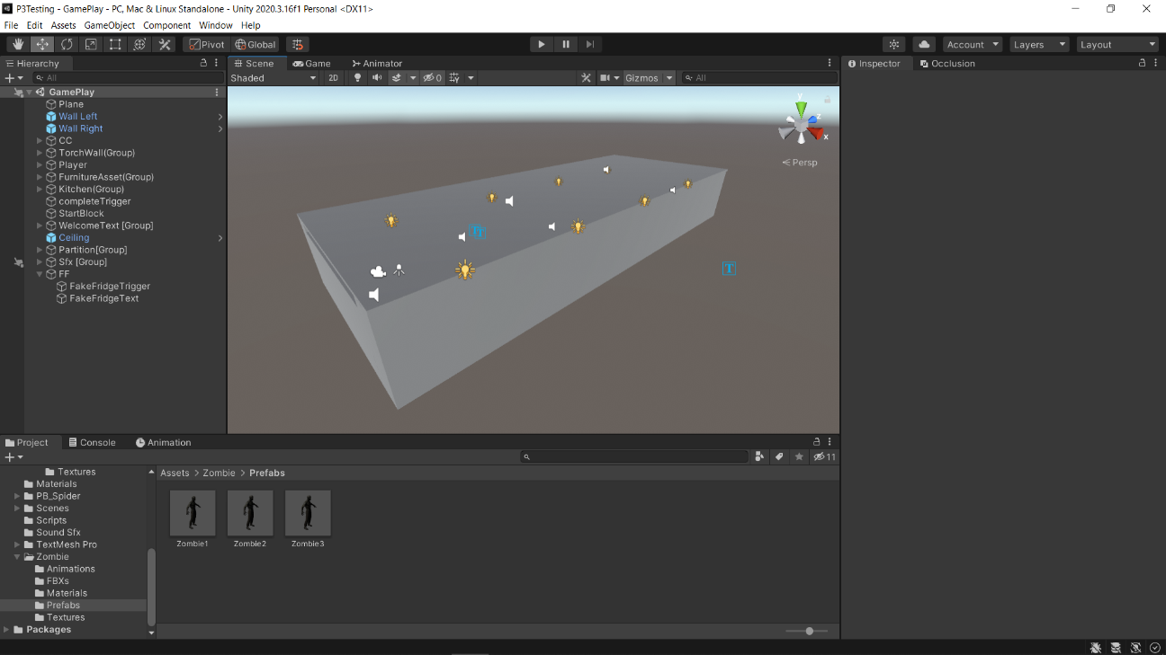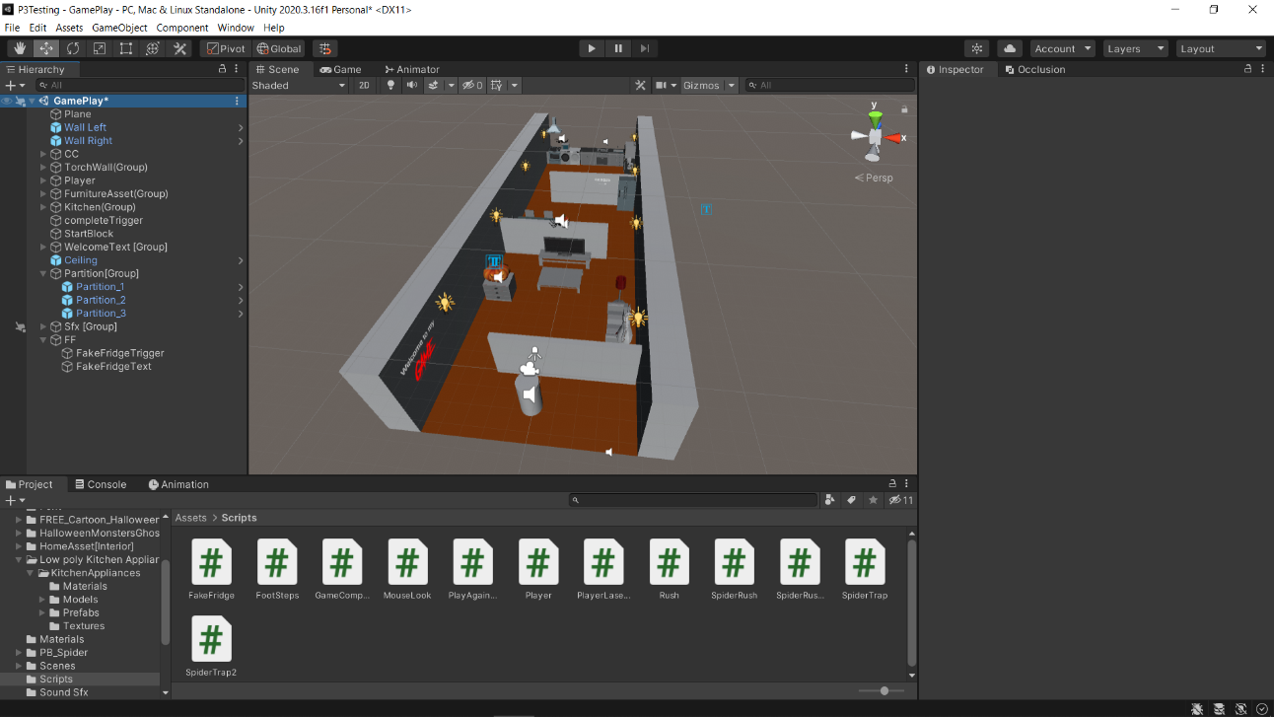

Figure 1: Isometric view in editor mode [Without Ceiling – Left & With Ceiling - Right]

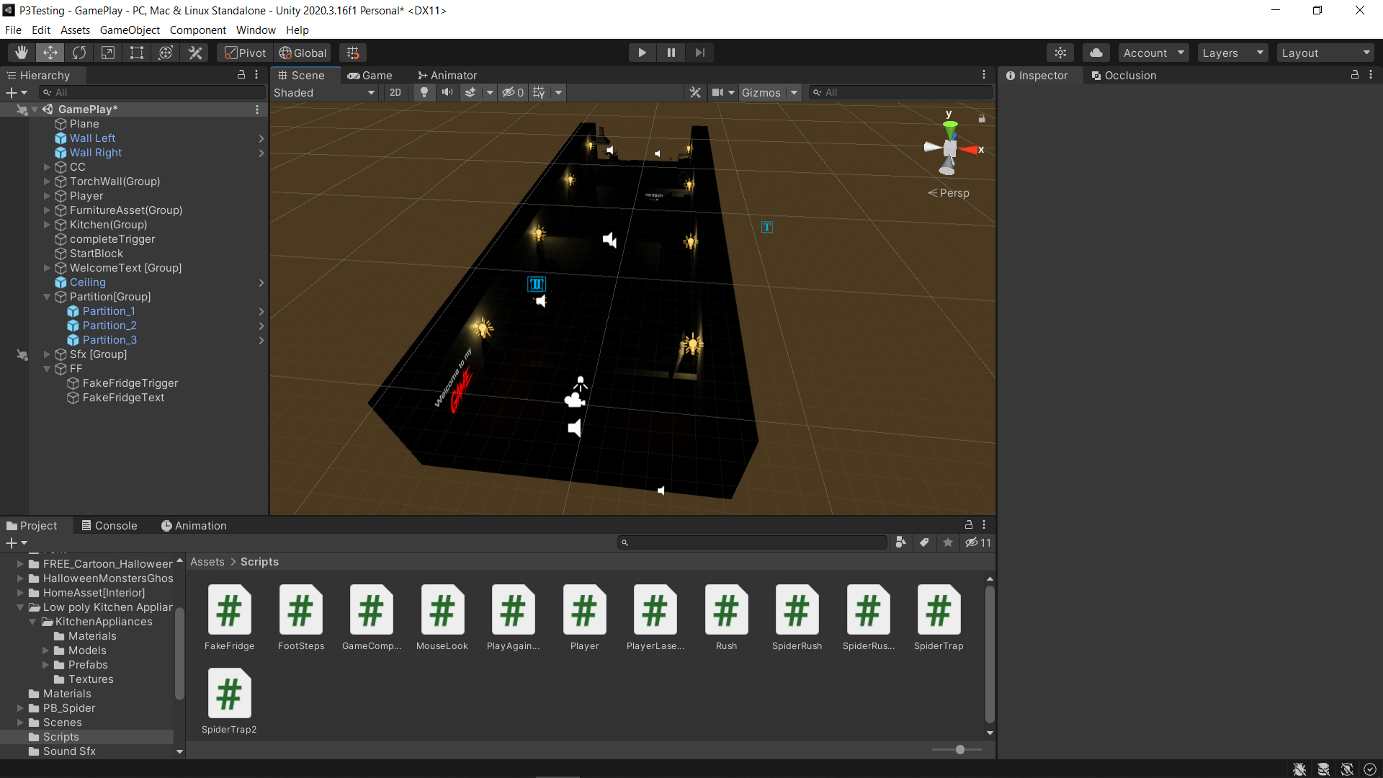

Figure 2: Isometric View in Editor Mode [Without Ceiling - Scene Lightning Off]

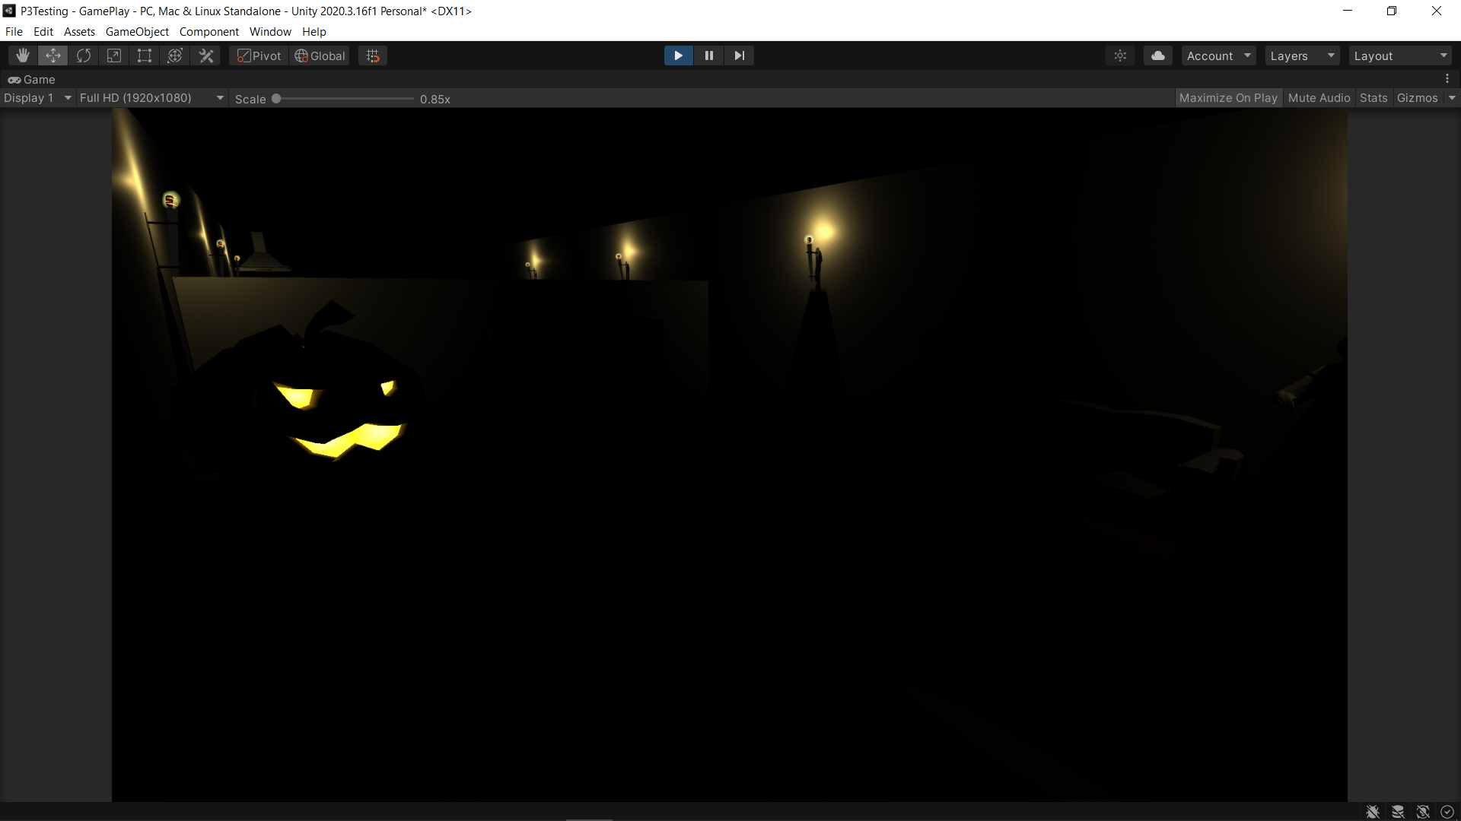

Figure 3: Play Mode View [Torchlight Off]

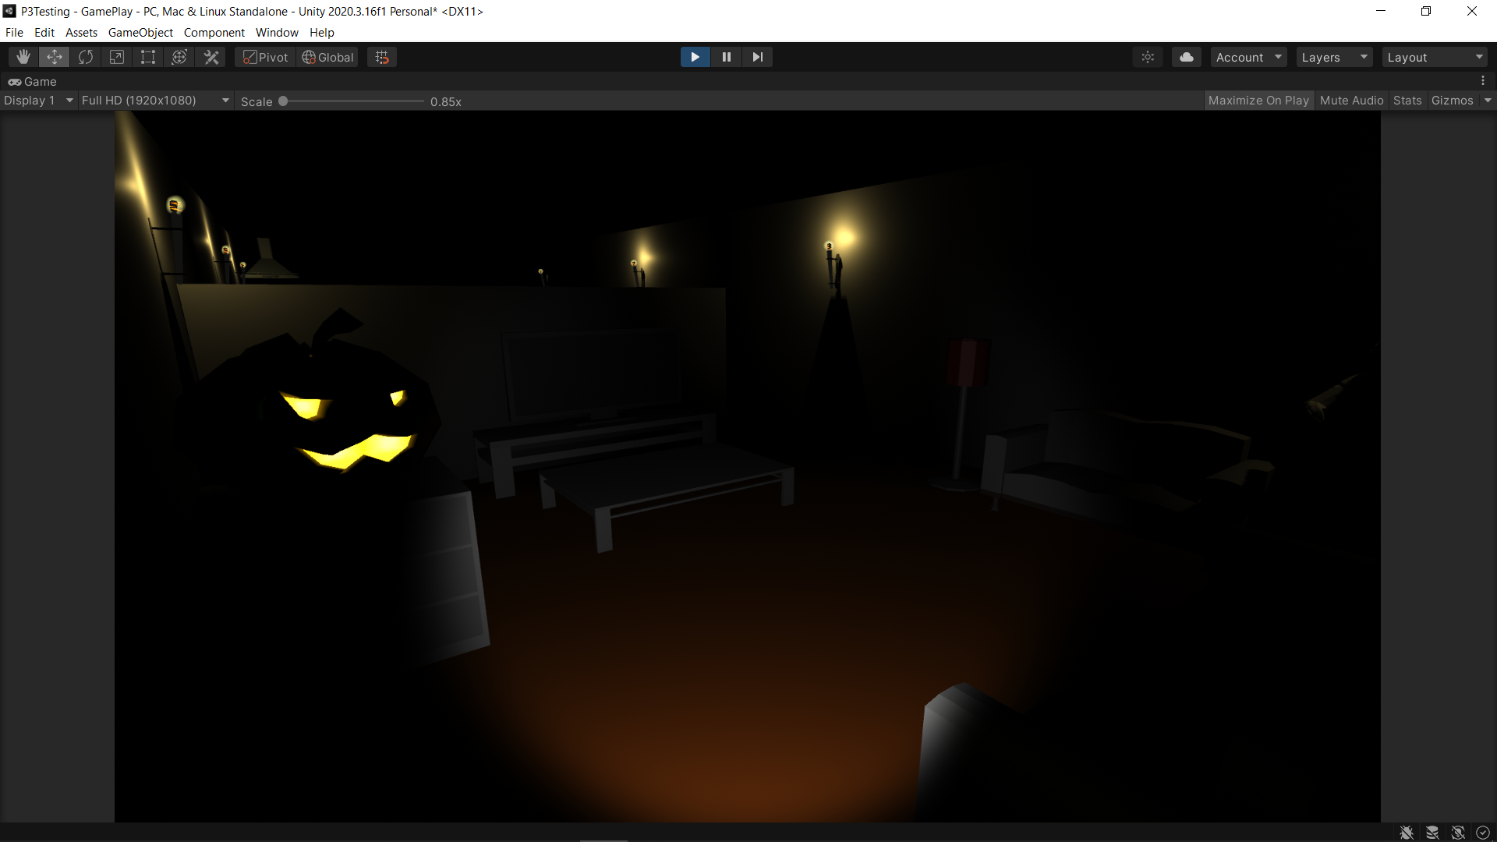

Figure 4: Play Mode View [Torchlight On]

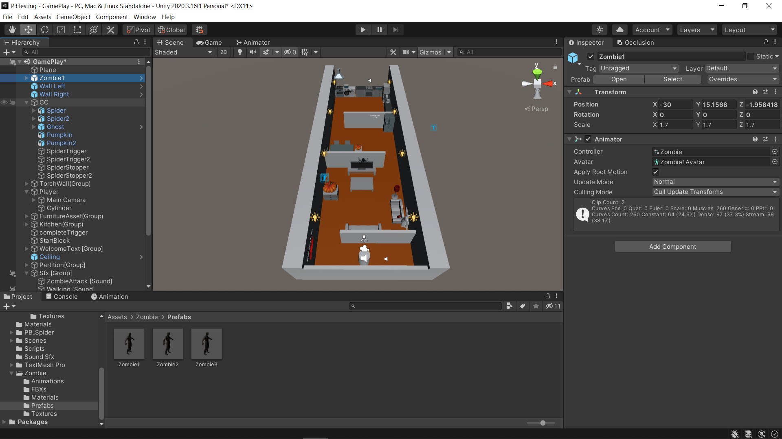

Zombie Troll

Spider

Ghost

Pumpkin

Area 2: Dining Area

Area 3: Kitchen

Area 1: Living Room

Figure 5: Design Breakdown

Moreover, the game is split into 3 sections like a typical home setup shown in Fig. 5 above. The player must advance in the dark with a torchlight without triggering the spooky objects as in Fig. 7 in order to reach to the fridge in the kitchen as it is the primary objective. The design breakdown also shows the placement and position of the game over spooky objects trigger including an extra zombie troll. More detailed walkthrough will be demonstrated in the demo video. Fig. 6 below shows some snippet of the prototype game flow.

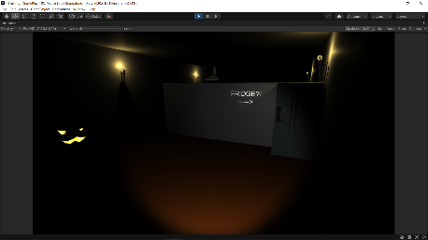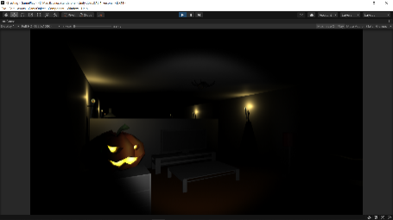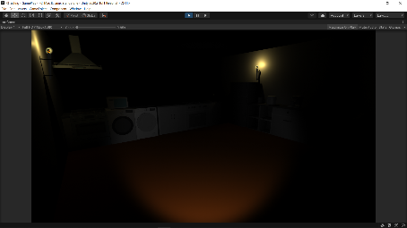

1. – Living Room

(2) – Dining Room

(3) – Kitchen

Figure 6: Game Flow in Play Mode

* The player would start from the living room, then advanced the area to the fridge in the kitchen through walking with the torchlight while carefully exploring the area and observe the sound generated from the spooky objects to avoid triggering them. The player will have to start again either if a spooky object is being triggered or fallen for the fake fridge zombie troll trap.

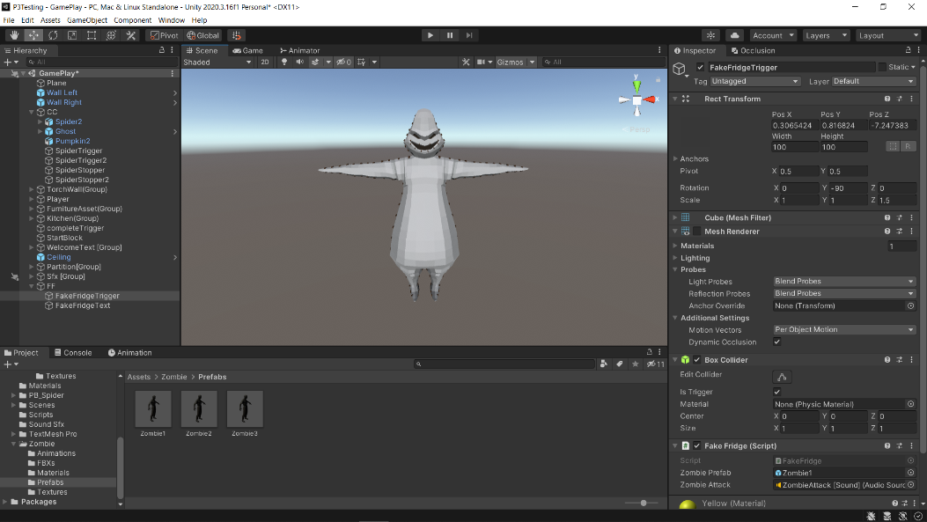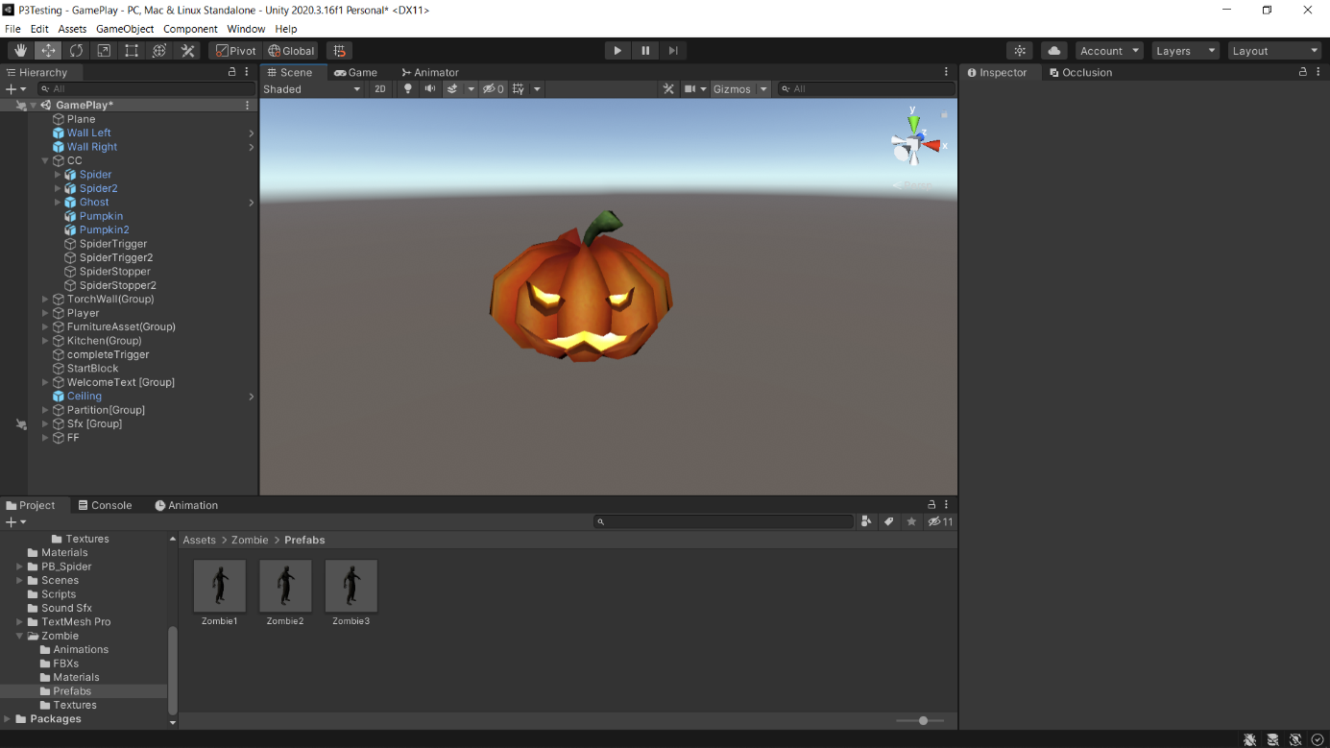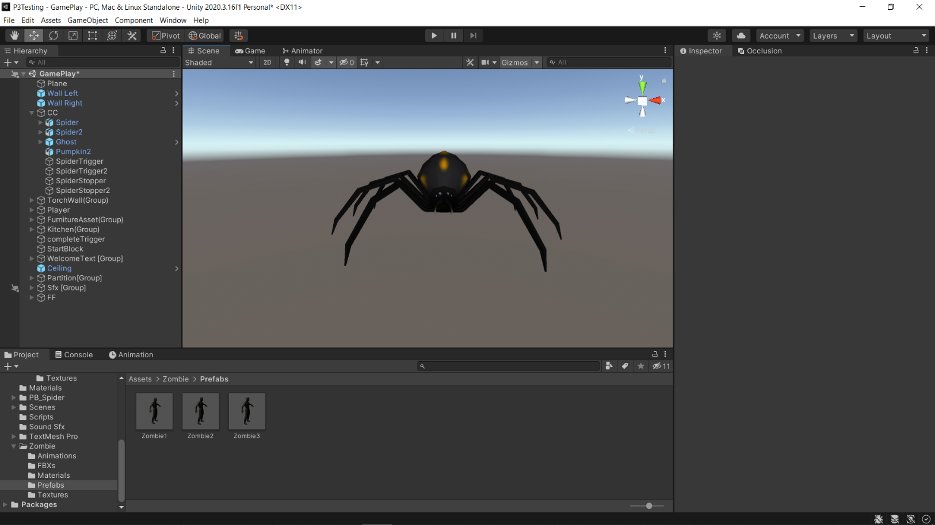

1. – Pumpkin

Source: Adapted from [12]

(2) – Ghost

Source: Adapted from [11]

(3) – Spider

Source: Adapted from [13]

Figure 7: Spooky Objects

According to Fig. 7, these are the spooky objects that will trigger the game over mechanism under different conditions. The players could use the information from the audio cues of the spooky objects as a guidance to advances the area easier. The mechanics for each object will be explained as below:

1. Pumpkin

* Sound: Beeping
* Trigger: [Game Over] When distance between the player and the pumpkin is approximately 3 metres.

**Beeping gradually become louder when player getting close to the pumpkin. (Inversely proportional)

** A maniacal laugh will appear when going into game over screen.

1. Ghost

* Sound: Ghost Ambience
* Trigger: [Game Over] When the player look direction is facing towards the ghost for approximately 7 seconds – regardless of torchlight on/off.

**The ghost ambience will appear when the player looks away after looking at the ghost as an indicator of alerting the ghost.

** A ghost cry will appear when jump scare rushing towards the user.

1. Spider

* Sound: Spider Hissing
  + - Trigger: [Game Over] When distance of the player and the spider between the ground and ceiling is approximately 3 metres.

**Hissing gradually become louder when player getting close to the spider. (Inversely proportional)

** A spider scream will appear indicated player has been bitten and with the player camera facing towards the spider.

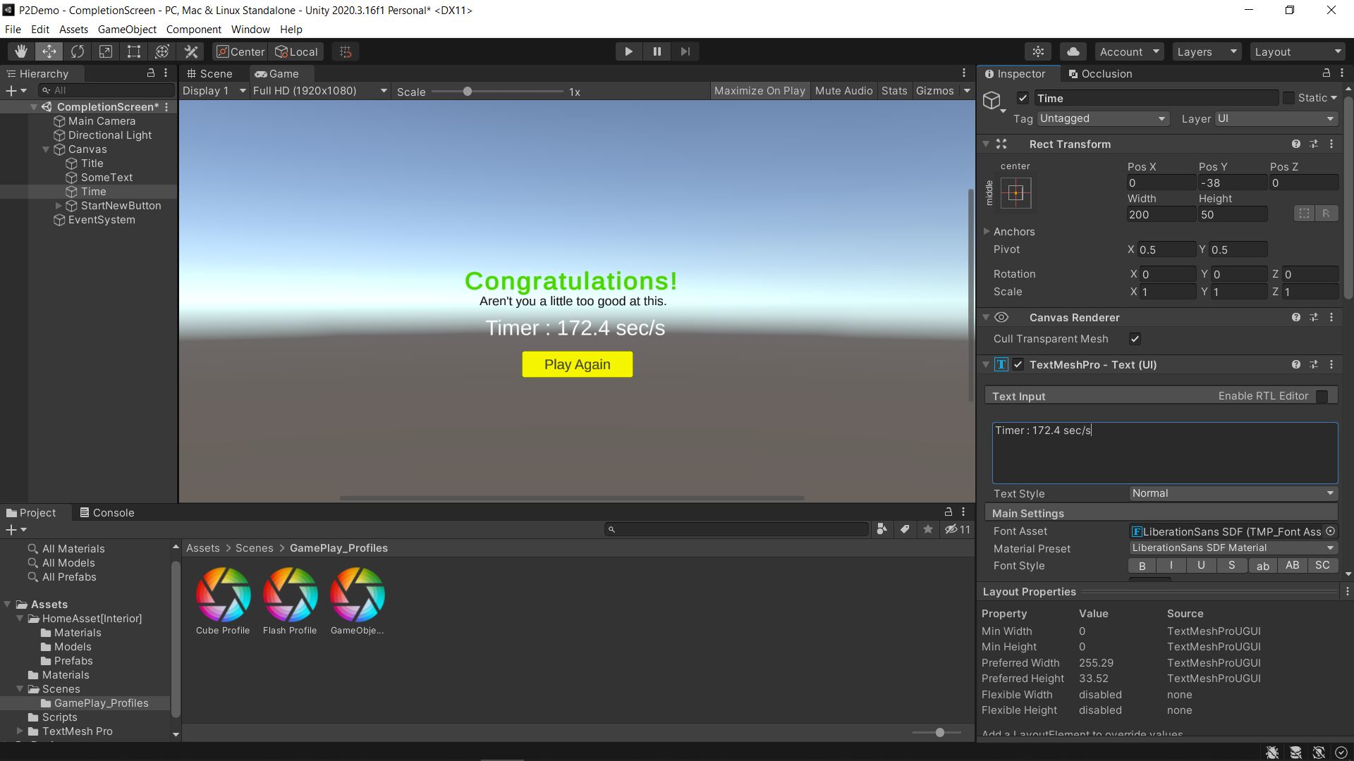

Figure 8: Game Completion Screen

To trigger game completion: the player must reach to the kitchen and approach the real fridge, a completion timer will be included as seen above in Fig. 8.

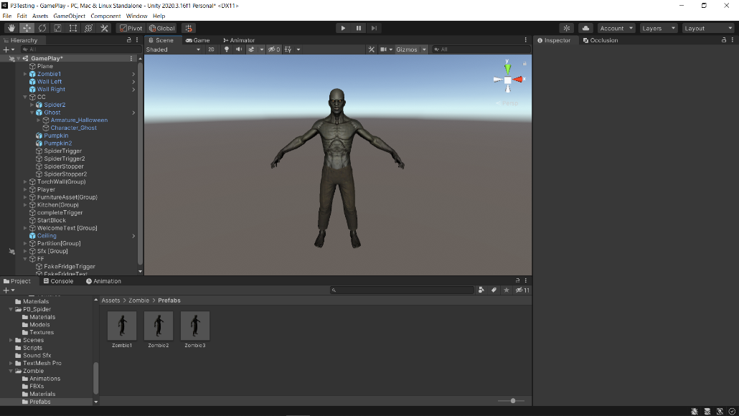

Figure 9: Zombie Troll

Source: Adapted from [14]

In addition, this prototype has also an extra easter egg, which is a zombie troll for approaching the fake fridge. The aim for including this easter egg is for me to see if:

* Will the participant approach the fake fridge after seeing the sceptical visual message and due to the primary objective of being “approach the fridge”?
* Will this mechanism trigger intense psychological reaction from the player for the next attempt onwards of playing more carefully and slower after experiencing a jump scare? (Particularly referencing to the James-Lange theory [33])

Furthermore, I would also want to include an insurance for increasing the likelihood of the participants receiving a good scare at least once by walking to the “fake fridge” if the gameplay is being a smooth-sailing or relatively a cakewalk to them.

The interactive prototype ideation and development processes are all well documented and explained in the weekly journals.

**The Testing Approach**

For the testing approach, I have included a snippet of my drafted testing plan shown in Fig. 10:

Figure 10: Snippets of Testing Plan Draft

The testing plan is a combination of controlled observation + interviews as briefly mentioned during Assignment 4 (Interactive Prototype 2 SoD - Testing Plan). However, the observation will be solely focusing on the participant state of mind including the natural behaviour under the influence of intense psychological responses towards spooky and scary objects. The mentioned heart rate criteria will not be performed as it seems unnecessary and inappropriate for my concept focus scope and I believe not much useful information could be extracted for insights during evaluation.

As usual, Time on Task (ToT) is included to record to completion time. Controlled observation is optimal for this prototype as there would be sound included as the main feature which the participant will be hearing the audio cues through a headphone peripheral device when interacting with the game. Hence, it is useful for me to observe what the users during the interaction that could help me answer these questions:

* does the user received information perceived as useful from the audio cues?
* will the user state of mind changes after hearing the audio cues?
* how will the user react after experiencing a jump scare?
* what approach does the user take after the first failure?

Interviews are lean towards gathering more of the participants afterthought and opinions with the prototype heuristics. This could help me to carry out a more in-depth analysis with reviewing how well or bad my “prototype game” is to the participants after making improvements. It is very useful to keep myself reminded that my prototype should be modified and improved not just for the sake of me thinking “I feel good about it” but rather it could achieve my goal when the participants are testing the prototype with a pleasant experience. ToT is still being used to record the time used of the participants when completing the primary objective. This helps me to measure and ensure that my prototype scale can be fit in a reasonable time duration (e.g., 3 ~ 4 minutes) for the testing session without the users spending excessive time testing a very complicated prototype for every iteration.

The testing session will be starting by briefing the participants my prototype concept along with an introduction. After that, I will provide a tutorial for the controls and challenges of how my prototype works and the participant will be asked to complete one single task to achieve the primary objective, which is sneaking to the fridge in the kitchen from the living room. The ideal feedback I would like to collect from the participants during testing session includes the participant responses and reactions towards the spooky objects (including zombie troll), completion time and afterthoughts.

The interview questions revolved around closed questions, open-ended questions, and game heuristic evaluation in a quantitative scale. The approach and flow for probing afterthought questions will start off by asking for the participant current feeling after experiencing a thrilling and spooky game as these will be good data for me to evaluate the aftermath and impact if the prototype could invoke intense psychological reaction or not. Following that would be questions that requires the participants to retrace their steps and share their feelings or thoughts with my game mechanisms and interactions, especially asking the participant to explain the game mechanics of the spooky objects and zombie troll if the participant “actually really understand” after a good scare. I have included a heuristic evaluation to gather some quantitative feedbacks for my game design. The last question would anything the participant “really want to say” about my prototype. This question is partly important to let me know if the participant really “like” or “dislike” something in this prototype, which are insights and information I could harness for my analysis and evaluation.

**Evaluation Outcomes & Reflection**

The observation was full of wonderful moments of the participants getting some good scare and bursting laughter from me. I noticed the participants were actually having some good time having fun even though they keep getting frightened and scared. Even though one participant keeps struggling with the audio cues without completing the primary objective, the other information provided are sufficient for my evaluation. The interview question will be used as additional information and cross-reference for a more precise and sound evaluation.

**Overall Analysis:**

1. Average Task Completion Time

123.3 sec/s ≈ 2 min 4 sec/s [2 out of 3 completed the goal]

** Success rate: 66.7%

Most of the participants spent approximate 1 to 3 minutes to complete the primary objective of this prototype (with only one participant not able to finish). From my deduction, I believe there are 3 reasons that causes the participants a longer playing time stated as below:

* The pathway design is a little too narrow to walk-on (participants that are weak with playing games struggles)
* The participant received a fair amount of emotional shock after being frightened by the jump scare objects (e.g., ghost, spider and zombie) that causes a longer recover time for them to be focused when continue playing the game
* The participant approaches the game in a slower and cautious manner after experiencing the first jump scare

Hence, it is reasonable for the participants to have a longer completion time after experiencing an intense psychological reaction stimulated by the external event of either a ghost jump scare, zombie troll or even spider scream. However, most of the participants still decided to continue playing the game despite being frightened and have the option to opt-out. I believe the gameplay experience for this prototype is very pleasant and successful.

1. A roller-coaster ride with this spooky horror game

All the three participants were deeply intrigued with this game setting despite having multiple minor “heart attacks” encountering the game objects, especially the spider and ghost jump scare. Most of them were still under the influence of an intense psychological reaction of nervous and anxiety after the encountering it the first time, but still being very focused playing the game for the further few attempts. The feedbacks on their feeling during the afterthought were mostly mutual, which they think it is “scary yet fun” at the same time, implying their mental journeys being basically a roller-coaster ride.

1. Tension kicking in with the audio cues

The intention of not explaining the audio cues prior during the testing session was to allow me to observe if the participants gain any information from the audio cues and what psychological impact it brings. The answers from the all the participants [P1, P2, P3] believes it servers as a warning of being in “danger”, which almost all of them started to play more cautiously and slower after the first few attempts. Even though only two participants understand the partial mechanism to the spooky objects that triggers game over, the audio cues itself is enough to let their minds subconsciously telling them “you’re in danger, play it safe and steady”. Overall, it did not provide much guidance for the players of how to avoid the game objects triggering the game over mechanism but does effectively affect their mental state of playing it with extra focus and passively.

1. Components leaving a mark behind for the participants

The torchlight feature has been the topping the favourite list among the participants as most of them think that the design and mechanics is an amazing and refreshing setup for this prototype. Participant [P1] gave credits to the zombie design as it was being so realistic that caught the participant off guard as the participant thought the goal is being achieved but never knew it was a fake. Both participant [P2] and [P3] have praised the implementation of the audio cues have successfully forcing them being tension and into an intense mental state which sort of draws out their “survival instinct” playing the game. It is definitely great to hear that the hard work of my “scaring mechanics” managed to pay off by invoking intense reaction from the users but could still be carry on by the participants.

1. Last word from the participants

I have summarized the participants’ thoughts into two key points:

1. Diversion instead of instant kill

Both participant [P1] and [P2] suggested a sort of mechanism that can temporarily protect the player or avoid death when being chased by the ghost or similar entities. As they think instant kill on every single spooky object would diminishes the gameplay experience which have to start the game all over again. Hence, both participants thought that some of the objects could be made less lethal allowing the player to be able to avoid the “death flag”, which would create more meaningful and interesting interactions.

1. Pathway width design issue

Participant [P3] was being a little annoyed by the constant deaths at area 2: dining room for all the attempts with not being able to stay far away from the pumpkin and the fake fridge at the same time to proceed forward to the kitchen. The participant believes the control is somewhat tough having the pathway being slightly too narrow as the participant is also not very good with playing games, turning all the attempts into a failure. Thus, participant [P3] recommended having a wider pathway width design could reduce the difficulty which increase the playability and experience for amateur test users.

1. Game Heuristic Evaluation (Average)
2. Game Mechanics (e.g., fake fridge): ≈3.67

**✓✓**

|  |  |  |  |  |  |  |
| --- | --- | --- | --- | --- | --- | --- |
| Dull |  |  |  |  |  | Interesting |

1. Player Control (in terms of freedom and perspective): ≈3.67

**✓✓**

|  |  |  |  |  |  |  |
| --- | --- | --- | --- | --- | --- | --- |
| Insufficient |  |  |  |  |  | Sufficient |

1. Immersion (related to spooky theme): 4.33

**✓✓**

|  |  |  |  |  |  |  |
| --- | --- | --- | --- | --- | --- | --- |
| Low |  |  |  |  |  | High |

1. Audio Cues (guidance): ≈4.67

|  |  |  |  |  |  |  |
| --- | --- | --- | --- | --- | --- | --- |
| Unclear |  |  |  |  | **✓✓** | Clear |

1. Replay-ability (replay value): 5

|  |  |  |  |  |  |  |
| --- | --- | --- | --- | --- | --- | --- |
| Low |  |  |  |  | **✓** | High |

The findings from this evaluation have shown that

* all the participants thought that the extra easter egg zombie fake fridge troll is an icing on the cake, somewhat giving out more of the spooky horror vibes
* all the participants believe that the player control is smooth and have achieved a typical setting for first-person view movement control
* all the participants are amazed with the objects used, environment setups and game mechanics design are closely appropriate for a spooky horror game that fits in the Halloween theme
* all the participants agreed that the audio cues serve as a very good indicator to inform them to be “cautious” even though they did not fully grasp more information about the trigger mechanism behind the spooky objects
* all the participants give good feedbacks about the overall game concept and mechanics and definitely loves to play it again

**Possible Changes For Further Iterations After Evaluation:**

* Retains necessary light sources fitting appropriate themes (e.g., torchlight, laser [security theme], fire torch [Halloween theme], etc.), omits all additional artificial lightning for a more immersive environment setup (more intense and eerie environment with minimal environmental lightning)
* Adding visual information (e.g., symbols) for audio cues allowing better interpretation by the users to understand the game mechanism themselves
* Include diversion mechanism allowing the players to seek temporary protection when being spotted by instant kill game objects
* Implementation smarter AI for enemy objects that would increase the interactions and elevate the gameplay experience
* Usage of the level system allowing more freedom for the users to choose their desired difficulties during first or continuous gameplay

**Summary:**

The hypothesis stands valid as the audio cues do prompts the users playing the game more cautious and slower while being influence going through a more intense psychological process such as anxiety and fear. The dark environment setup that lets off a more spooky and eerie ambience have also provided some impact of delivering the users mental state into a more stressful situation, which the mind would naturally brings out its “survival instinct” to inform the users “to be careful” while advancing the are to complete the primary objective (sneaking into the kitchen) with the current developed prototype.

The ultimate goal of audio cues prompting the users to play in the game in a slow and safe manner seems to be a success but fails at delivering information that the users can be interpreted as useful for guiding them. Like I mentioned above in the analysis section [3], the participants were not able to extract useful information from the audio cues to help them better playing the game. Therefore, I concluded the main reason along with my observation I due to the audio cues have heavily affected the users mental state being under a stressful situation which has been subconsciously taken over by the “survival instinct” even though they are being focused playing the game, resulting the participant judgment are slightly clouded by their emotions especially after receiving a shock from a few good jump scares.

This also has brought my thought towards how a sound could affect someone mentally under a good timing and setup, which I have personally seen it during my testing session that one of my participants got frightened almost three times by the “low poly scary objects”, and thereby confirm my inference of the impact of an audio cues of a spooky sound could definitely stir up one’s fear that played a very crucial role in this prototype. This prototype has taught me the wonders of audio cues and how closely it relates to psychology under a specific environment, which could also be used for research purposes with the appropriate tools and setup.

Despite the participants keep getting frightened by my prototype, it never stops myself and them laughing it off, because the participants just love playing it over and over again with more finesse, included myself when looking at their expression getting shocked and frightened. The constructive feedbacks above from the participants have proved that I have provided sufficient information for the participants to complete the primary objective of the prototype while also having the necessary components for my overall design and concept.

**Testing Plan**

According to my initial testing plan for the remaining prototype stated in the Interactive Prototype 2 SoD Report – Testing Plan, I have slightly deviated from the original course of testing the audio cues in response to the heart rate.

Therefore, this current prototype will basically be implementing audio cues on all included spooky objects to observe how the psychological response of the users after experiencing a sudden jump scare or good fright will influence and affect the users approaching the game in the further attempts instead of:

1. ~~monitoring the heart rate~~

** More detailed description is written in the week 11 journal on miro board.

**Miro Link**

https://miro.com/app/board/o9J_l4T1G9Y=/

**Video Link**

https://youtu.be/GBwyAFP64Lg

**Appendices - IEEE Reference**

1. Smart Penguins - GameDev. *Night Lighting and Headlights | Unity Tutorial - 4 Minutes.* Accessed: Sep. 14 , 2021. [Online Video]. Available: https://youtu.be/9p4xgzbFpjg
2. Brackeys. *FIRST PERSON MOVEMENT in Unity - FPS Controller.* Accessed: Oct. 6, 2021. [Online Video]. Available: https://youtu.be/_QajrabyTJc
3. Jimmy Vegas. *HOW TO MAKE SOUND GET LOUDER THE CLOSER YOU GET - DOPPLER EFFECT UNITY TUTORIAL*. Accessed: Oct. 18, 2021. [Online Video]. Available: https://youtu.be/eQphjWreQ0U
4. Jimmy Vegas. *Mini Unity Tutorial - How To Add Sound Effects*. Accessed: Oct. 17, 2021. [Online Video]. Available: https://youtu.be/JnbDxG04i7c
5. “Laser beam help needed.” forum.unity.com. https://forum.unity.com/threads/laser-beam-help-needed.650929/ (accessed Oct. 17, 2021).
6. EYEmaginary. *Unity 3D - How to add Footsteps with sound [C#]*. Accessed: Oct. 18, 2021. [Online Video]. Available: https://youtu.be/ih8gyGeC7xs
7. “Make Object Move to/follow Another Object? (plus turn towards it)” answers.unity.com

https://answers.unity.com/questions/56251/make-object-move-tofollow-another-object-plus-turn.html (accessed Oct. 12, 2021).

1. “Another Danger” dafont.com

https://www.dafont.com/another-danger.font (accessed Oct. 17, 2021).

1. A.Infinite. “Kitchen Appliance - Low Poly”. unityAssetStore.com.

https://assetstore.unity.com/packages/3d/props/electronics/kitchen-appliance-low-poly-180419 (Accessed Oct. 13, 2021).

1. B.Vector. “Ultimate Low Poly Dungeon”. unityAssetStore.com.

https://assetstore.unity.com/packages/3d/environments/dungeons/ultimate-low-poly-dungeon-143535 (Accessed Oct. 13, 2021).

1. Codewart Game Assets. “LOWPOLY - Ghost”. unityAssetStore.com.

https://assetstore.unity.com/packages/3d/characters/lowpoly-ghost-187863 (Accessed Oct. 15, 2021).

1. Lumo-Art 3D. “FREE Cartoon Halloween Pack - Mobile/VR”. unityAssetStore.com.

https://assetstore.unity.com/packages/3d/environments/fantasy/free-cartoon-halloween-pack-mobile-vr-45896 (Accessed Oct. 16, 2021).

1. [prism bucket]. “Animated Spider”. unityAssetStore.com.

https://assetstore.unity.com/packages/3d/characters/animals/insects/animated-spider-22 986 (Accessed Oct. 17, 2021).

1. Pxltiger. “Zombie”. unityAssetStore.com.

https://assetstore.unity.com/packages/3d/characters/humanoids/zombie-30232 (Accessed Oct. 19, 2021).

1. “Access TextMeshPro text through script?” forum.unity.com

https://forum.unity.com/threads/access-textmeshpro-text-through-script.527992/ (accessed Aug. 31, 2021).

1. “how to round a float to 2 decimal places in unity code example” newbevdev.com

https://newbedev.com/csharp-how-to-round-a-float-to-2-decimal-places-in-unity-code-example (accessed Aug. 31, 2021).

1. “Maniacal Witches Laugh” SoundBible.com.

https://soundbible.com/1129-Maniacal-Witches-Laugh.html (accessed Oct. 19, 2021).

1. “Sound Effects / Beasts – Monster Insect Scream 1” epidemicsound.com.

https://www.epidemicsound.com/track/YH8HKzpp7W/ (accessed Oct. 19, 2021).

1. “Sound Effects / Wildlife – Monkey Spider 11” epidemicsound.com.

https://www.epidemicsound.com/track/HlKNxjgHcY/ (accessed Oct. 19, 2021).

1. “Download Free Zombie Sound Effects – Zombie Aggressive Attack A5 Sound Effect” fesliyanstudios.com.

https://www.fesliyanstudios.com/royalty-free-sound-effects-download/zombie-174 (accessed Oct. 19, 2021).

1. “Download Free Footsteps Sound Effects – Sneaker Shoe On Concrete Floor Medium Pace 1 Sound Effect” fesliyanstudios.com.

https://www.fesliyanstudios.com/royalty-free-sound-effects-download/footsteps-31 (accessed Oct. 19, 2021).

1. “Sound Effects / Beeps – Beep 23” epidemicsound.com.

https://www.epidemicsound.com/track/QBmBuuNp25/ (accessed Oct. 19, 2021).

1. “Sound Effects / Ghosts – Ghost Cry” epidemicsound.com.

https://www.epidemicsound.com/track/41Eu8soakB/ (accessed Oct. 19, 2021).

1. “Sound Effects / Ghosts – Ghost Appearance” epidemicsound.com.

https://www.epidemicsound.com/track/sYpyhAduIn/ (accessed Oct. 19, 2021).

1. “SceneManager.LoadScene” docs.unity3d.com.

https://docs.unity3d.com/ScriptReference/SceneManagement.SceneManager.LoadScene.html (accessed Aug. 31, 2021).

1. “AudioSource.volume” docs.unity3d.com.

https://docs.unity3d.com/ScriptReference/AudioSource-volume.html (accessed Oct. 17, 2021).

1. “Regenerating Health Over Time.” answers.unity.com

https://answers.unity.com/questions/368113/regenerating-health-over-time.html (accessed Sep. 12, 2021).

1. “Object.Instantiate” docs.unity3d.com.

https://docs.unity3d.com/ScriptReference/Object.Instantiate.html (accessed Aug. 21, 2021).

1. “Light” docs.unity3d.com. https://docs.unity3d.com/ScriptReference/Light.html (accessed Sep. 9, 2021).
2. “Application.Quit” docs.unity3d.com. https://docs.unity3d.com/ScriptReference/Application.Quit.html (accessed Sep. 21, 2021).
3. “Vector3.Distance” docs.unity3d.com.

https://docs.unity3d.com/ScriptReference/Vector3.Distance.html (accessed Oct. 12, 2021).

1. Ba Duy. *Simple laser in unity*. Accessed: Sep. 18, 2021. [Online Video]. Available: https://youtu.be/kzHNUT9q4JE
2. K.Kathia. “The James Lange Theory of Emotion”. pyschologynoteshq.com. https://www.psychologynoteshq.com/jameslangetheoryofemotion (accessed Oct 21, 2021).
3. S.McCollum. “Your Brain on Music: Chills & Thrills”. kennedy-center.org. https://www.kennedy-center.org/education/resources-for-educators/classroom-resources/media-and-interactives/media/music/your-brain-on-music/your-brain-on-music/your-brain-on-music-chills-and-thrills/ (accessed Oct 5, 2021)
4. “Chalkboard Background”. slidesgo.com. https://slidesgo.com/theme/chalkboard-background#search-Education&position-5&results-1404 (accessed Oct 24, 2021)

**Appendices**

**Testing Session Participant 1 Transcript [P1]**

Attempts:8

ToT - Task Completion Time (only completed attempt): 172.2 sec/s

Observation:

The participant was proceeding very fast for the first 4 attempts and did not know why he keeps dying. The participant knows there are audio cues but does not know the information it provided which causes the participant to keep trying all over again. The participant was frightened by zombie jump scare he triggered when reaching the fake fridge. This has resulted in causing the participant being more tense and playing the game slower from the 5th attempt onwards. The participant started to move very slowly when hearing the audio volume being at the highest and move slightly faster when the volume is getting lower.

1. What is your current feeling after experiencing this survival horror sneaking game?

I am still confused even after completing the goal. I could not understand what the audio cues are trying to tell me. All I can guess is that I am sort of in “danger” when I hear the audio is very loud and I decided just to move very slow when proceeding.

1. Can you please list down all the game over object audio cues and trigger reason respectively?

(Let them know all the mechanisms if they did not answer all of it correctly)

No. I do not know the game over triggers for all the respective objects. My best guess is the pumpkin is making a beep sound and I hear a screeching sound from the spider on the ceiling. I just forgot everything after I saw the spider appearing in front of me.

1. Is there any part in this prototype that catches your interest?

(In terms of you thinking it being good or bad?)

I will give credit for the zombie that suddenly appears in front of the fridge. That was scary. I only realized the visual wording of the “fridge” being sort of a troll after getting the zombie scare. This is definitely a good one.

1. Can you please rate the following aspects?
2. Game Mechanics (e.g., fake fridge)

|  |  |  |  |  |  |  |
| --- | --- | --- | --- | --- | --- | --- |
| Dull |  |  |  | **✓** |  | Interesting |

1. Player Control (in terms of freedom and perspective)

|  |  |  |  |  |  |  |
| --- | --- | --- | --- | --- | --- | --- |
| Insufficient |  |  | **✓** |  |  | Sufficient |

1. Immersion (related to spooky theme)

|  |  |  |  |  |  |  |
| --- | --- | --- | --- | --- | --- | --- |
| Low |  |  | **✓** |  |  | High |

1. Audio Cues (guidance)

|  |  |  |  |  |  |  |
| --- | --- | --- | --- | --- | --- | --- |
| Unclear |  |  |  | **✓** |  | Clear |

1. Re-playability (replay value)

|  |  |  |  |  |  |  |
| --- | --- | --- | --- | --- | --- | --- |
| Low |  |  |  |  | **✓** | High |

1. To conclude this session, any final thoughts on suggestion, improvements, or your overall experience?

(Catches your interest? – good or bad?)

I prefer having a jump option that could avoid the object, especially like having a safe spot I can go to when to zombie attack me so I can continue instead of starting all over again.

**Testing Session Participant 2 Transcript [P2]**

Attempts:4

ToT - Task Completion Time (only completed attempt): 74.4 sec/s

Observation:

Attempt 1: The participant did not seem to know what the beeping sound implies and received its first game over straightaway after crossing the partition.

Attempt 2: The participant started moving more cautiously and slowly but got frightened by the ghost jump scare.

Attempt 3: I believed the participant is a little traumatised with the previous few attempts and now proceed while facing the floor but still got shocked by another spider jump scare.

Attempt 4: The participant was sceptical of the fake fridge being a troll and has prepared mentally to explore the fake fridge, which eventually turn out that his suspicion is true and but still got slightly frightened by it.

Attempt 5: The participant then managed to breeze through the whole game towards the end after knowing all the game mechanics.

1. What is your current feeling after experiencing this survival horror sneaking game?

To be honest, the ghost jump scare got me good. I basically freaked out and was on “super high alert” mode after that onwards. The beeping sound did get as I believed I am getting too close to the pumpkin which my mind keeps telling to “stay away from it”.

1. Can you please list down all the game over object audio cues and trigger reason respectively?

(Let them know all the mechanisms if they did not answer all of it correctly)

I believe the pumpkin let off a beeping sound and the volume is affected by the distance which will be the loudest when very close to it.

The ghost will make a sound after you looked at it at least once but I do not know what triggers the jump scare.

The spider works the same as the pumpkin, which will make a screeching sound and loudest when very close to it.

1. Is there any part in this prototype that catches your interest?

(In terms of you thinking it being good or bad?)

I think the audio cues do its work one way or another, even if I am not entirely sure what kind of warning it is offering me, it still makes me more nervous which keep me in check when moving forward.

1. Can you please rate the following aspects?
2. Game Mechanics (e.g., fake fridge)

|  |  |  |  |  |  |  |
| --- | --- | --- | --- | --- | --- | --- |
| Dull |  |  | **✓** |  |  | Interesting |

1. Player Control (in terms of freedom and perspective)

|  |  |  |  |  |  |  |
| --- | --- | --- | --- | --- | --- | --- |
| Insufficient |  |  |  | **✓** |  | Sufficient |

1. Immersion (related to spooky theme)

|  |  |  |  |  |  |  |
| --- | --- | --- | --- | --- | --- | --- |
| Low |  |  |  |  | **✓** | High |

1. Audio Cues (guidance)

|  |  |  |  |  |  |  |
| --- | --- | --- | --- | --- | --- | --- |
| Unclear |  |  |  |  | **✓** | Clear |

1. Re-playability replay value)

|  |  |  |  |  |  |  |
| --- | --- | --- | --- | --- | --- | --- |
| Low |  |  |  |  | **✓** | High |

1. To conclude this session, any final thoughts on suggestion, improvements, or your overall experience?

(Catches your interest? – good or bad?)

I would suggest having a way or method to include a diversion for trigger such as the ghost jump scare that can be avoid with hiding inside a cabinet instead of an instant kill unless it is intentional.

**Testing Session Participant 3 Transcript [P3]**

Attempts:6

ToT - Task Completion Time (only completed attempt): DNF (Did not Finish)

Observation:

Attempt 1: The participant did not know what happened after receiving the first game over by getting too close to the pumpkin.

Attempt 2: The participant was moving more cautiously while paying attention and confused after getting the spider jump scare.

Attempt 3 & 4: The participant keeps dying on the same spot around the fake fridge area which was being too close to the second pumpkin

Attempt 5: The participant tried to manoeuvre around that area but still die from being too close to the second pumpkin.

Attempt 6: The participant was frustrated, and I decided to call it off as I believe it the information on this participant is sufficient for my evaluation.

1. What at is your current feeling after experiencing this survival horror sneaking game?

I am just annoyed with myself keep getting stuck and dying at the second pumpkin area. I also feel a chill down the spine as when the spider suddenly appears in front of me as I really hate spiders!

1. Can you please list down all the game over object audio cues and trigger reason respectively?

(Let them know all the mechanisms if they did not answer all of it correctly)

I am pretty sure the pumpkin makes a beep sound and will gradually getting louder when you are getting closer and eventually die.

I did not know about the ghost mechanics as I only barely see it once in the corner as my mind just tell me “There is a ghost, don’t look at it.

I know the spider make a hiss sound and perhaps will die when getting close, similar to the pumpkin.

1. Is there any part in this prototype that catches your interest?

(In terms of you thinking it being good or bad?)

The sound elements are actually a good audio cues for me personally, as it sort of keep telling me to be aware of danger when moving forward, which I will definitely look around the room with the torchlight to see what is actually happening and making all these noises.

1. Can you please rate the following aspects?
2. Game Mechanics (e.g., fake fridge)

|  |  |  |  |  |  |  |
| --- | --- | --- | --- | --- | --- | --- |
| Dull |  |  |  | **✓** |  | Interesting |

1. Player Control (in terms of freedom and perspective)

|  |  |  |  |  |  |  |
| --- | --- | --- | --- | --- | --- | --- |
| Insufficient |  |  |  | **✓** |  | Sufficient |

1. Immersion (related to spooky theme)

|  |  |  |  |  |  |  |
| --- | --- | --- | --- | --- | --- | --- |
| Low |  |  |  |  | **✓** | High |

1. Audio Cues (guidance)

|  |  |  |  |  |  |  |
| --- | --- | --- | --- | --- | --- | --- |
| Not helpful |  |  |  |  | **✓** | Helpful |

1. Re-playability (replay value)

|  |  |  |  |  |  |  |
| --- | --- | --- | --- | --- | --- | --- |
| Low |  |  |  |  | **✓** | High |

1. To conclude this session, any final thoughts on suggestion, improvements, or your overall experience?

(Catches your interest? – good or bad?)

Just a suggestion for increasing the pathway width, I know there is a reason to make people thinking “the pathway is hard to walk which you want them to move slowly” but I think having it a little wider would allow people that are not game-oriented like me having an easier time, just because I really want to finish it!